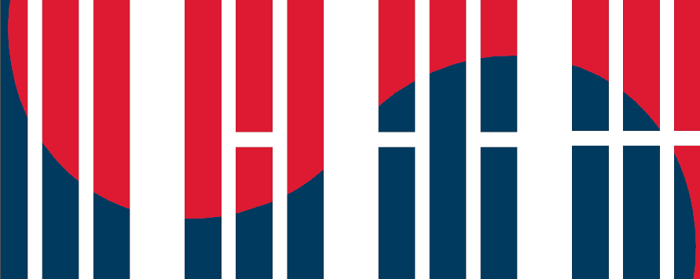
GWIKS WORKSHOP SCHEDULE

Date: May 23 – 24, 2017
Location: 1957 E Street NW, Washington DC, 20052, Suite 503, Conference Room

Tuesday, May 23

9:20 AM - 9:50 AM: Breakfast

9:50 AM - 10:15 AM: Introductions

10:15 AM - 12:00 PM: Social and Cultural Approaches to U.S.-Korea Relations

Presenters:

Dajeong Chung, The College of William and Mary, “From Dependency to Self-Sufficiency: American Relief Food to the Korean Peripheries, 1964-1968.”

Jeong Min Kim, New York University, “South Korea’s Wartime Black Market: Sexual Exchanges and the Everyday Economy during the Korean War.”

Commentary:

Arissa Oh, Boston College

12:00 PM - 1:00 PM: Lunch

1:00 PM - 2:45 PM: Politics, Security and U.S.-South Korean Relations

Presenters:

Jooeun Kim, Georgetown University, “The Vietnam War and U.S. Credibility on the Korean Peninsula.”

Khue Dieu Do, Seoul National University, “The Carter Zeal versus the Carter Chill: U.S. Policy towards the Korean Peninsula in the Carter Era”

Commentary:

Ji-young Lee, American University

Mitchell Lerner, The Ohio State University

3:00 PM - 4:45 PM: Security and Development in South Korea

Presenters:

Patrick Chung, Brown University, “From Supply Lines to Supply Chains: Busan, the Korean War, and the Rise of Global Logistics”

Peter Banseok Kwon, Harvard University, “Korea’s Search for Defense Autonomy: Park Chung Hee’s Defense Industry Development and South Korea’s Challenges to U.S. Arm Policies, 1968-1979.”

Commentary:

Gregg Brazinsky, The George Washington University

6:30 PM: Dinner

Rasika West End Restaurant

Wednesday, May 24

9:45 - 10:15 AM: Breakfast

10:15 AM - 12:00 PM: Domestic Politics and Globalization in South Korea

Presenters:

Steven Denney, The University of Toronto, “The Micro-Foundations of Democratic Support in Contemporary South Korea.”

Darcie Draudt, The Johns Hopkins University, “Multiculturalism as State Policy and Citizenship Practices in ‘Global Korea’.”

Commentary:

Ji-young Lee, American University

Harris Mylonas, The George Washington University

12:00 PM - 12:45 PM: Lunch

12:45 PM - 2:30 PM: North Korea and the World

Presenters:

Benjamin Young, The George Washington University, “A Microhistory of the Korean Conflict: North and South Korean Students at the Tehran Foreign School, 1983”

Thomas Stock, University of California, Los Angeles, “Under Attack: Fraternal Criticism and the Development of North Korean Ideology.”

Commentary:

Mitchell Lerner, The Ohio State University

James F. Person, Woodrow Wilson International Center for Scholars

2:30 PM - 3:30 PM: Wrapping Up and Future Plans

