Friday, Feb. 9, 2018
Compiling a History of North Korea in the 21st Century: Methodology of Fact Selection and Analysis
with
Sergei O. Kurbanov
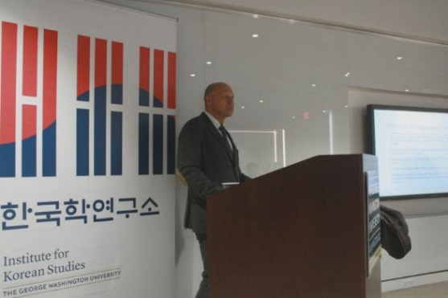

Moderator: Professor Gregg A. Brazinsky

Gregg A. Brazinsky is Associate Professor of History and International Affairs and Deputy Director of GW Institute for Korean Studies. His research seeks to understand the diverse and multi-faceted interactions among East Asian states and between Asia and the United States. He is the author of Nation Building in South Korea: Koreans, Americans, and the Making of a Democracy (University of North Carolina Press, 2007) and Winning the Third World: Sino-American Rivalry during the Cold War (University of North Carolina Press, 2017). He served as Interim Director of the GW Institute for Korean Studies during the Spring 2017 semester.

The process of understanding any society begins with the study of its history. As long as a culture's history is already published, it is not a difficult task to read and learn it. The North Korean case is very important, but also very difficult. The DPRK does not have a universal historical narrative covering the various aspects of social and economic life, especially within the last 20 years. Thus, any researcher who has set himself the task of writing the history of the DPRK in recent years faces the problem of selecting facts and interpreting them. This talk will discuss universal and culturally localized methods of fact selection and give possible variants of the sequence of important North Korean events covering the period from 2000 to early 2018.

Sergei O. Kurbanov is a professor and the chair of the newly established Department of Korean Studies at St. Petersburg University. In 1997, he developed and opened the "Korean History Major" BA Program. His spheres of interest are wide, including the general history of Korea (with books published in 2002 and 2009), Korean Confucianism (book in 2007), and the everyday lives of North and South Koreans in 1987 - 2000s (books in 2013 and 2017).

