Monday, Feb. 12, 2018
The South Korean Media in the Post-Truth Era
with
Youn Kuk Jung

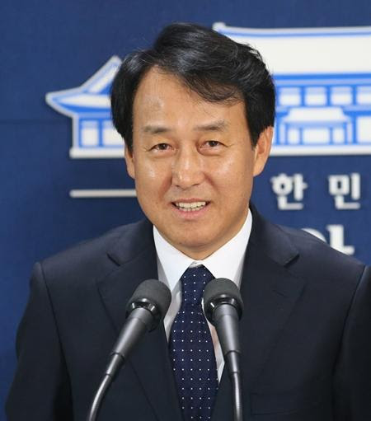

Moderator: Professor Jisoo M. Kim

Jisoo M. Kim is Korea Foundation Associate Professor of History, International Affairs, and East Asian Languages and Literatures at the George Washington University and Director of the GW Institute for Korean Studies. She received her Ph.D. in Korean History from Columbia University. She is a specialist in gender and legal history of early modern Korea. Her broader research interests include gender and sexuality, crime and justice, literary representations of the law, history of emotions, vernacular, and gender writing. She is the author of The Emotions of Justice: Gender, Status, and Legal Performance in Chosŏn Korea (University of Washington Press, 2015), which was awarded the 2017 James Palais Prize of the Association for Asian Studies. She is also the co-editor of The Great East Asian War and the Birth of the Korean Nation by JaHyun Kim Haboush (Columbia University Press, 2016).

How will the current "post-truth" trend (the notion that individual sentiments and ideals precede objective truth) shape South Korean society? Seeing and believing only the information one wants to, the so-called "fake news" seems to have a huge influence on the framework of news and journalism in South Korea. In considering this, does text messaging expand the participants of communication? Or does it reduce communication to that only between enclosed groups of people who share the same beliefs? Together, we will reflect upon "the South Korean media in the post-truth era."

Mr. Youn Kuk Jung is currently Visiting Scholar at the GW Institute for Korean Studies (GWIKS). His research interests lie in the development of Korean media, looking specifically at journalism and the government in Korea and the United States, and the role of journalism in the development of Korea. Prior to his affiliation with GWIKS, he worked for the South Korean government as presidential spokesperson at the Blue House. Youn Kuk Jung has experience working as a TV broadcasting journalist for 28 years at Munhwa Broadcasting Corporation (MBC) in Seoul, South Korea as a news anchor, London correspondent, and TV debate program host. He earned his Master's in Media and Public Relations at Yonsei University in 2005, and his Bachelor's in German Language at Chungang University in 1986.

